BIT 4107 – Mobile Application Development
ENHANCED PROFESSIONAL STUDENT LOGBOOK
Student Name: DANIEL REIN
Admission Number: BIT/2024/32708
School/Faculty: COMPUTING & INFORMATICS
Programme: BSCIT
Academic Year: FOURTH
Semester: TWO
Lecturer: MICHAEL NYORO
Phone Number: 0791047455

Table of content
Week 1: Introduction to Mobile Application Development 3
Figure 1.1: Installation of Android Studio virtual device 3
Tools/Software Used 3
Personal Reflection 3
Week 2: Mobile Development Environment 4
Figure 2.1: Testing of "Hello Android” 4
Personal Reflection 4
Week 3: User Interface Design 5
Figure 3.1: Screen splash 5
Figure 3.2: Home dashboard screen 7
Figure 3.3: Place list 8
Figure 3.4: Place details 8
Figure 3.5: About screen 10
Week 4: Event Handling and User Interaction 11
Figure 4.1: Kotlin code for navigation events 11
Figure 4.2: Splash screen entry point 12
Figure 4.3: Main dashboard interface 12
Week 5: Data Management 14
Figure 5.1: Local data storage configuration 14
Figure 5.2: FavoritesManager.kt for persistent storage 14
Figure 5.3: Places List screen in emulator 15

Week 1: Introduction to Mobile Application Development

Figure 1.1: Installation of Android Studio virtual device
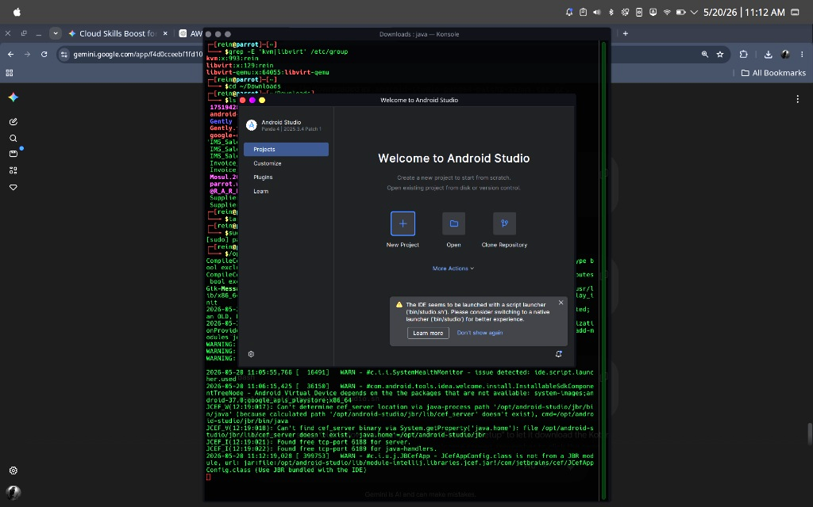

Tools/Software Used
Android Studio

Personal Reflection
Installing Android Studio on Parrot OS was challenging due to KVM and hypervisor setup, but ultimately successful. I utilized Kotlin and Jetpack Compose for UI development, moving away from traditional XML layouts. I also established a fully functional Gradle build and ADB deployment workflow, ensuring efficient development for my mobile applications.

Week 2: Mobile Development Environment

Figure 2.1: Testing of "Hello Android”
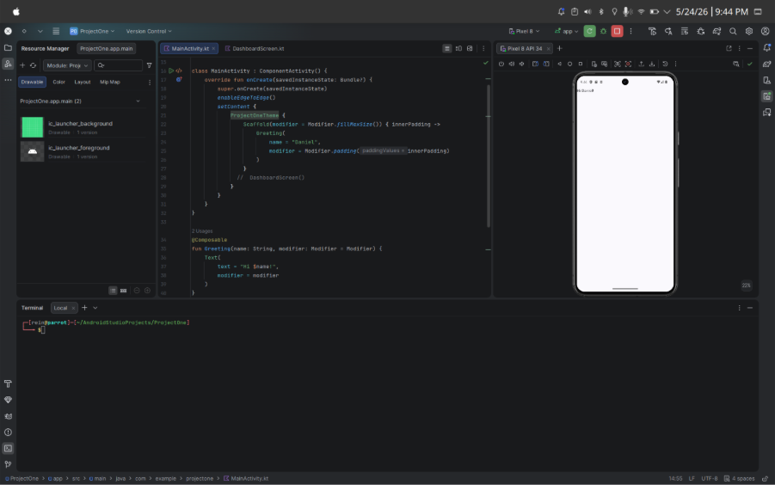

Personal Reflection
Working with the emulator was enjoyable. I used the Pixel 8 for the "Hello Android" app and successfully tested it on my physical phone via ADB. While the emulator and phone performed similarly, the initial compilation took a long time due to the Gradle installation.

Week 3: User Interface Design

Figure 3.1: Screen splash

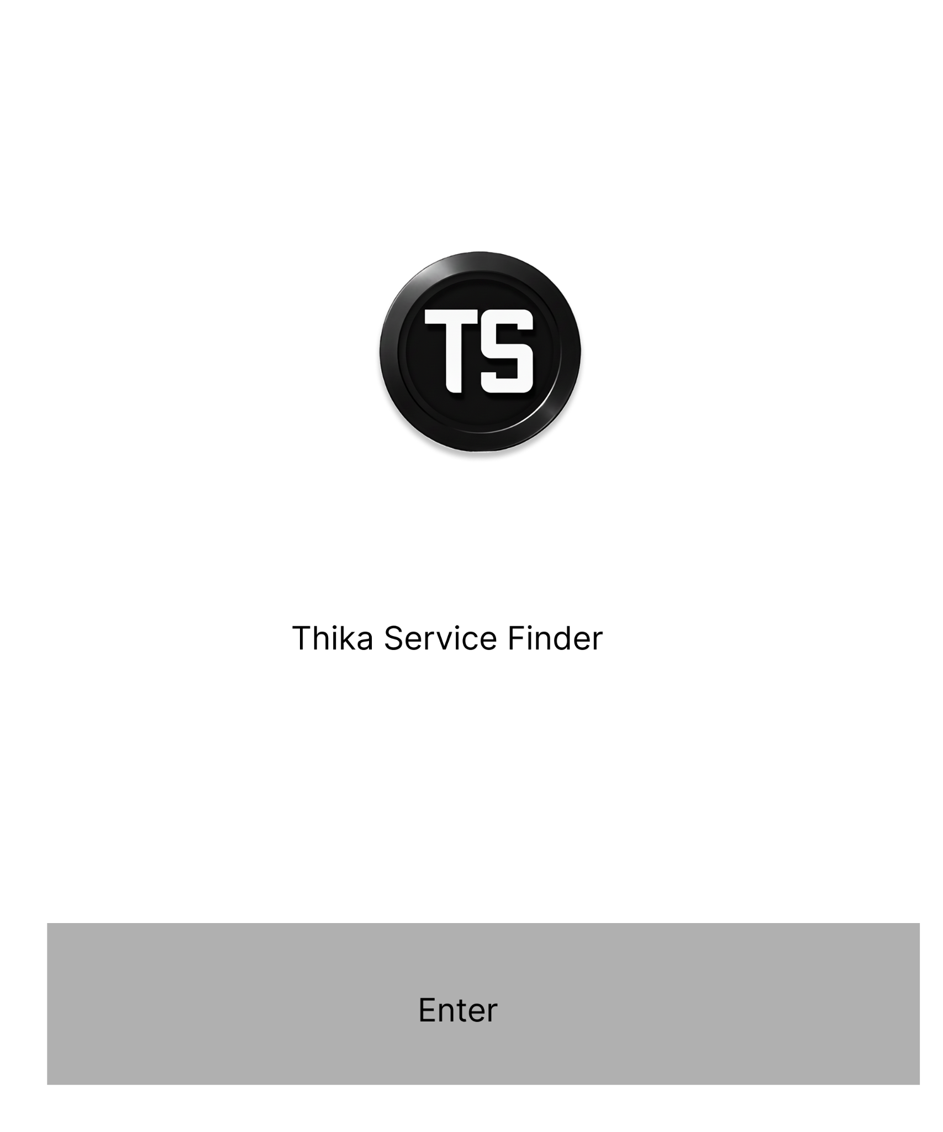

Figure 3.2: Home dashboard screen
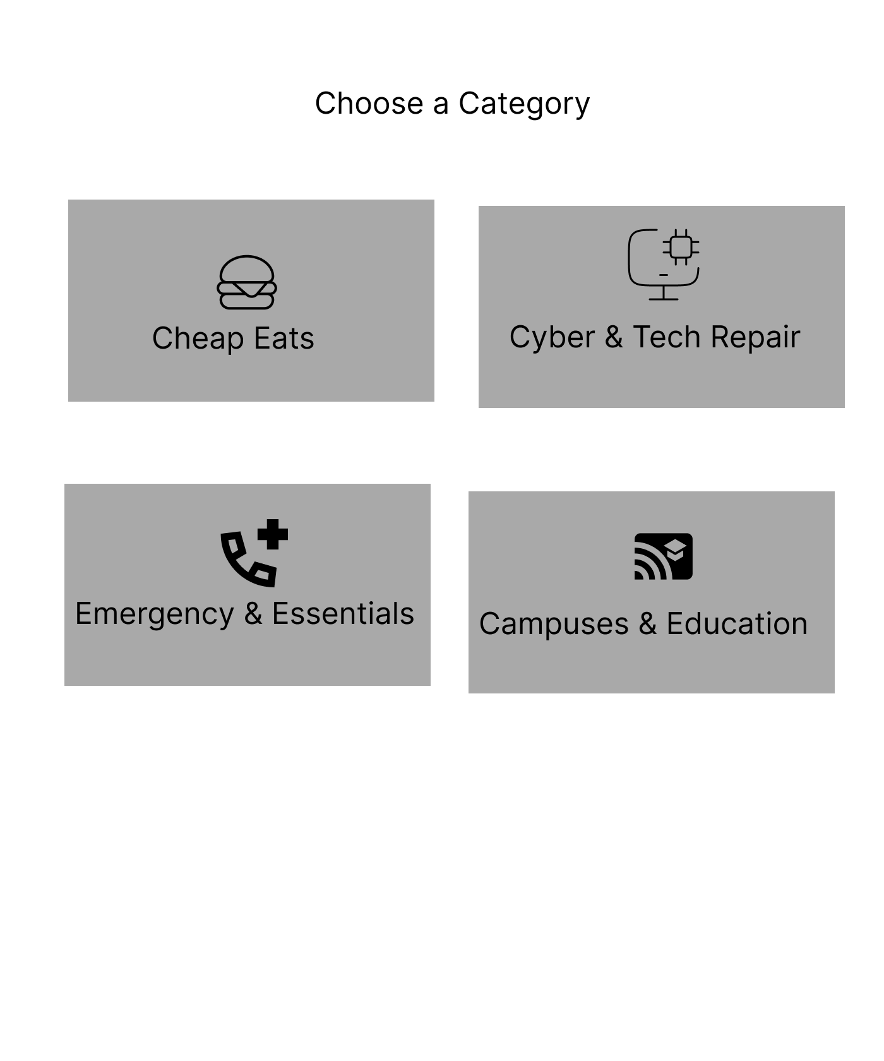

Figure 3.3: Place list
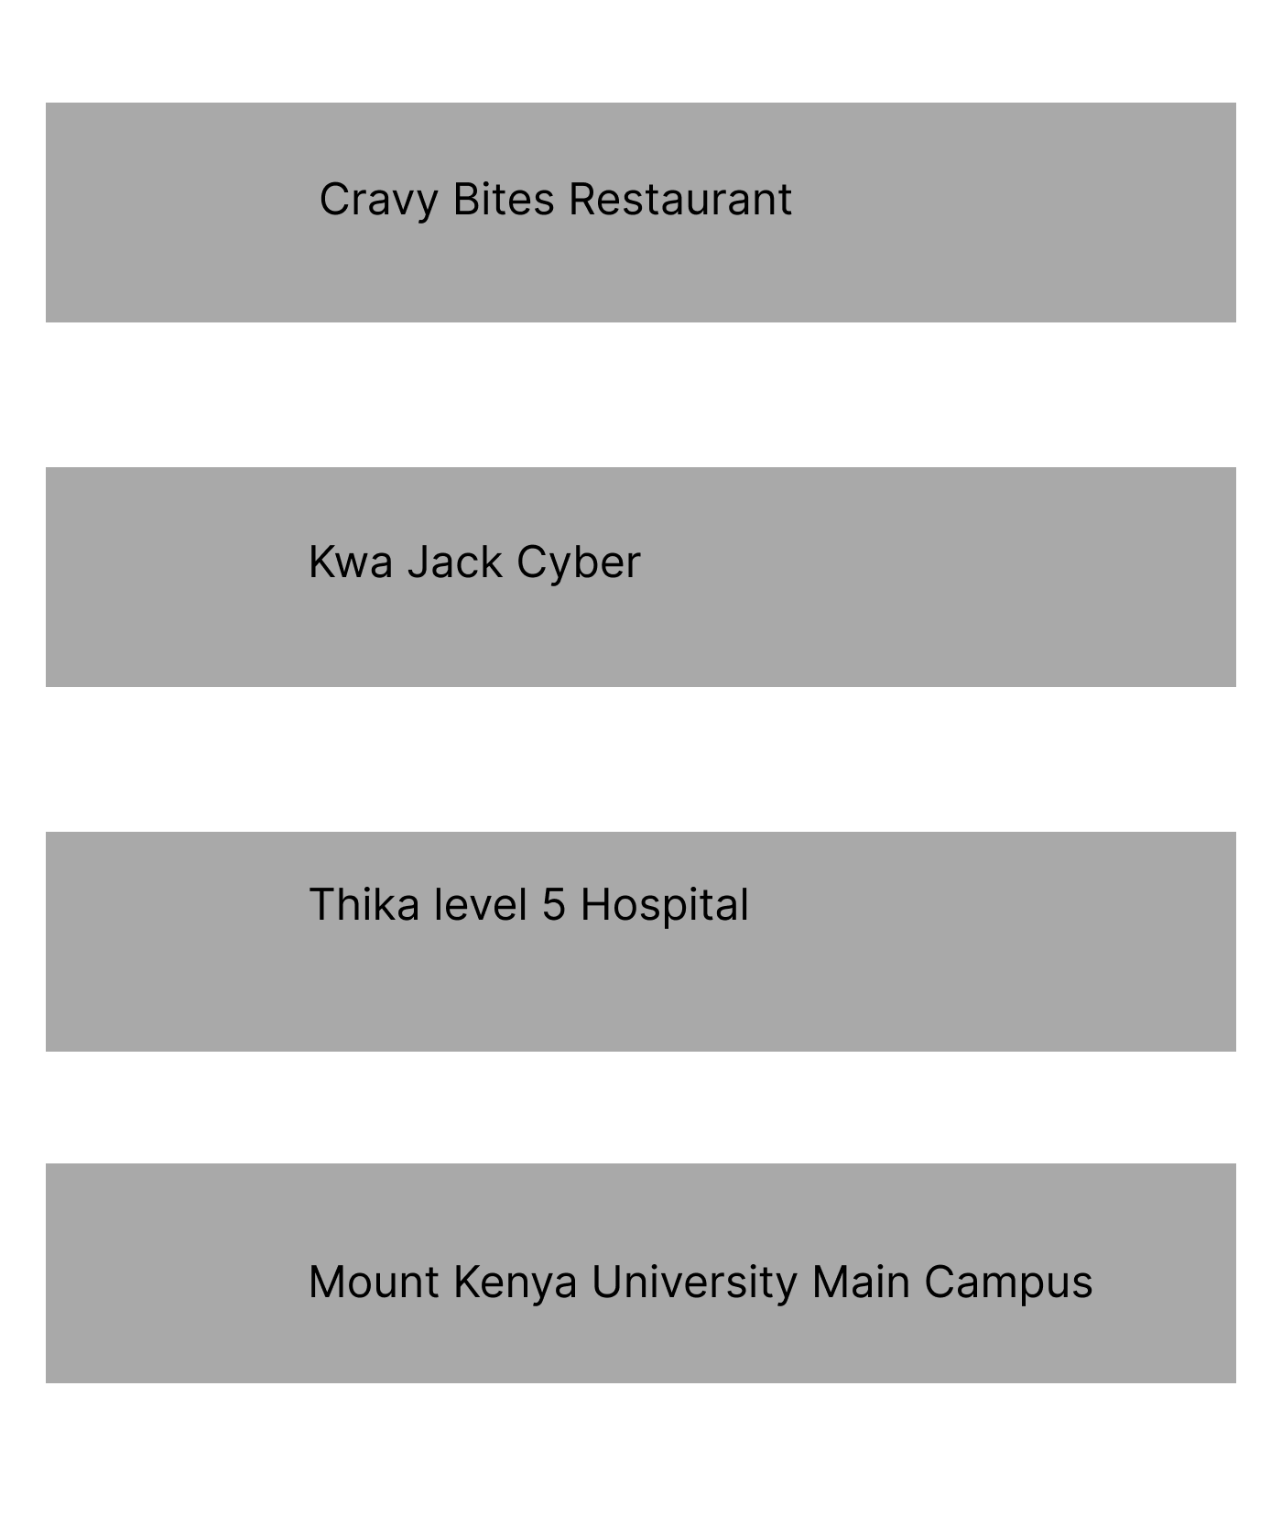

Figure 3.4: Place details

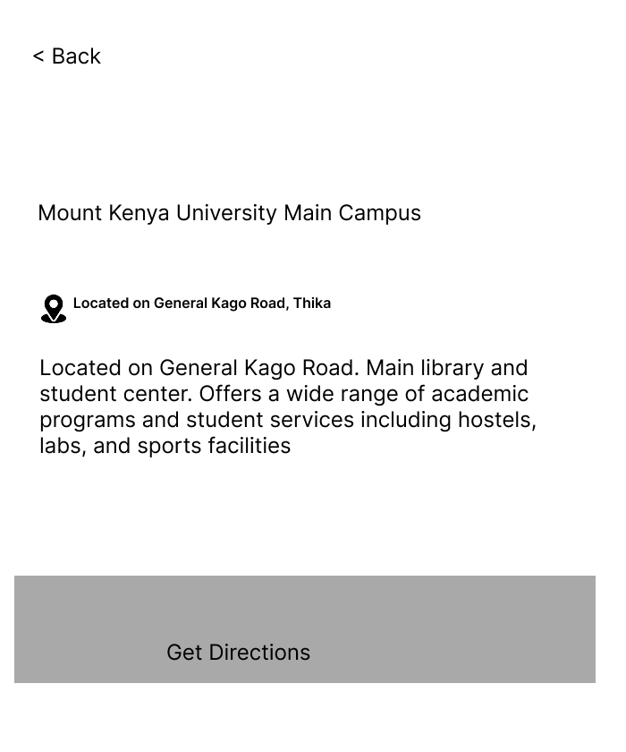

Figure 3.5: About screen

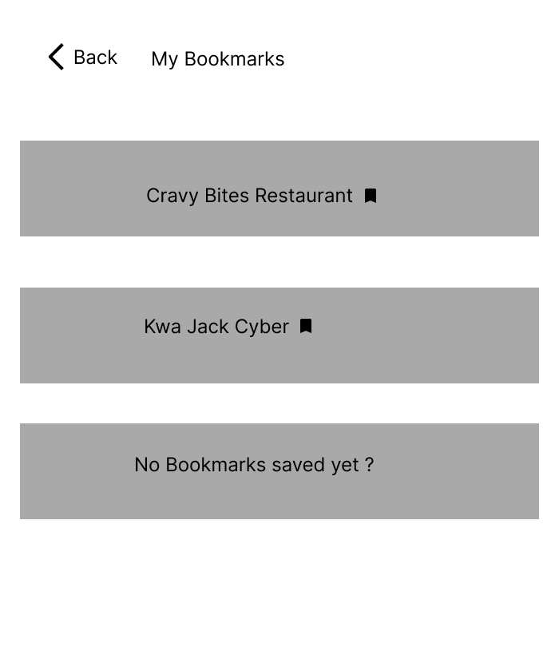

Personal Reflection
Creating Figma wireframes was initially challenging, but mastering shortcuts streamlined the process. Seeing an app concept come to life through wireframing was insightful. Designing the splash screen was particularly instructive, and leveraging Figma's AI tools significantly simplified the refinement process.

Week 4: Event Handling and User Interaction

Figure 4.1: Kotlin code for navigation events

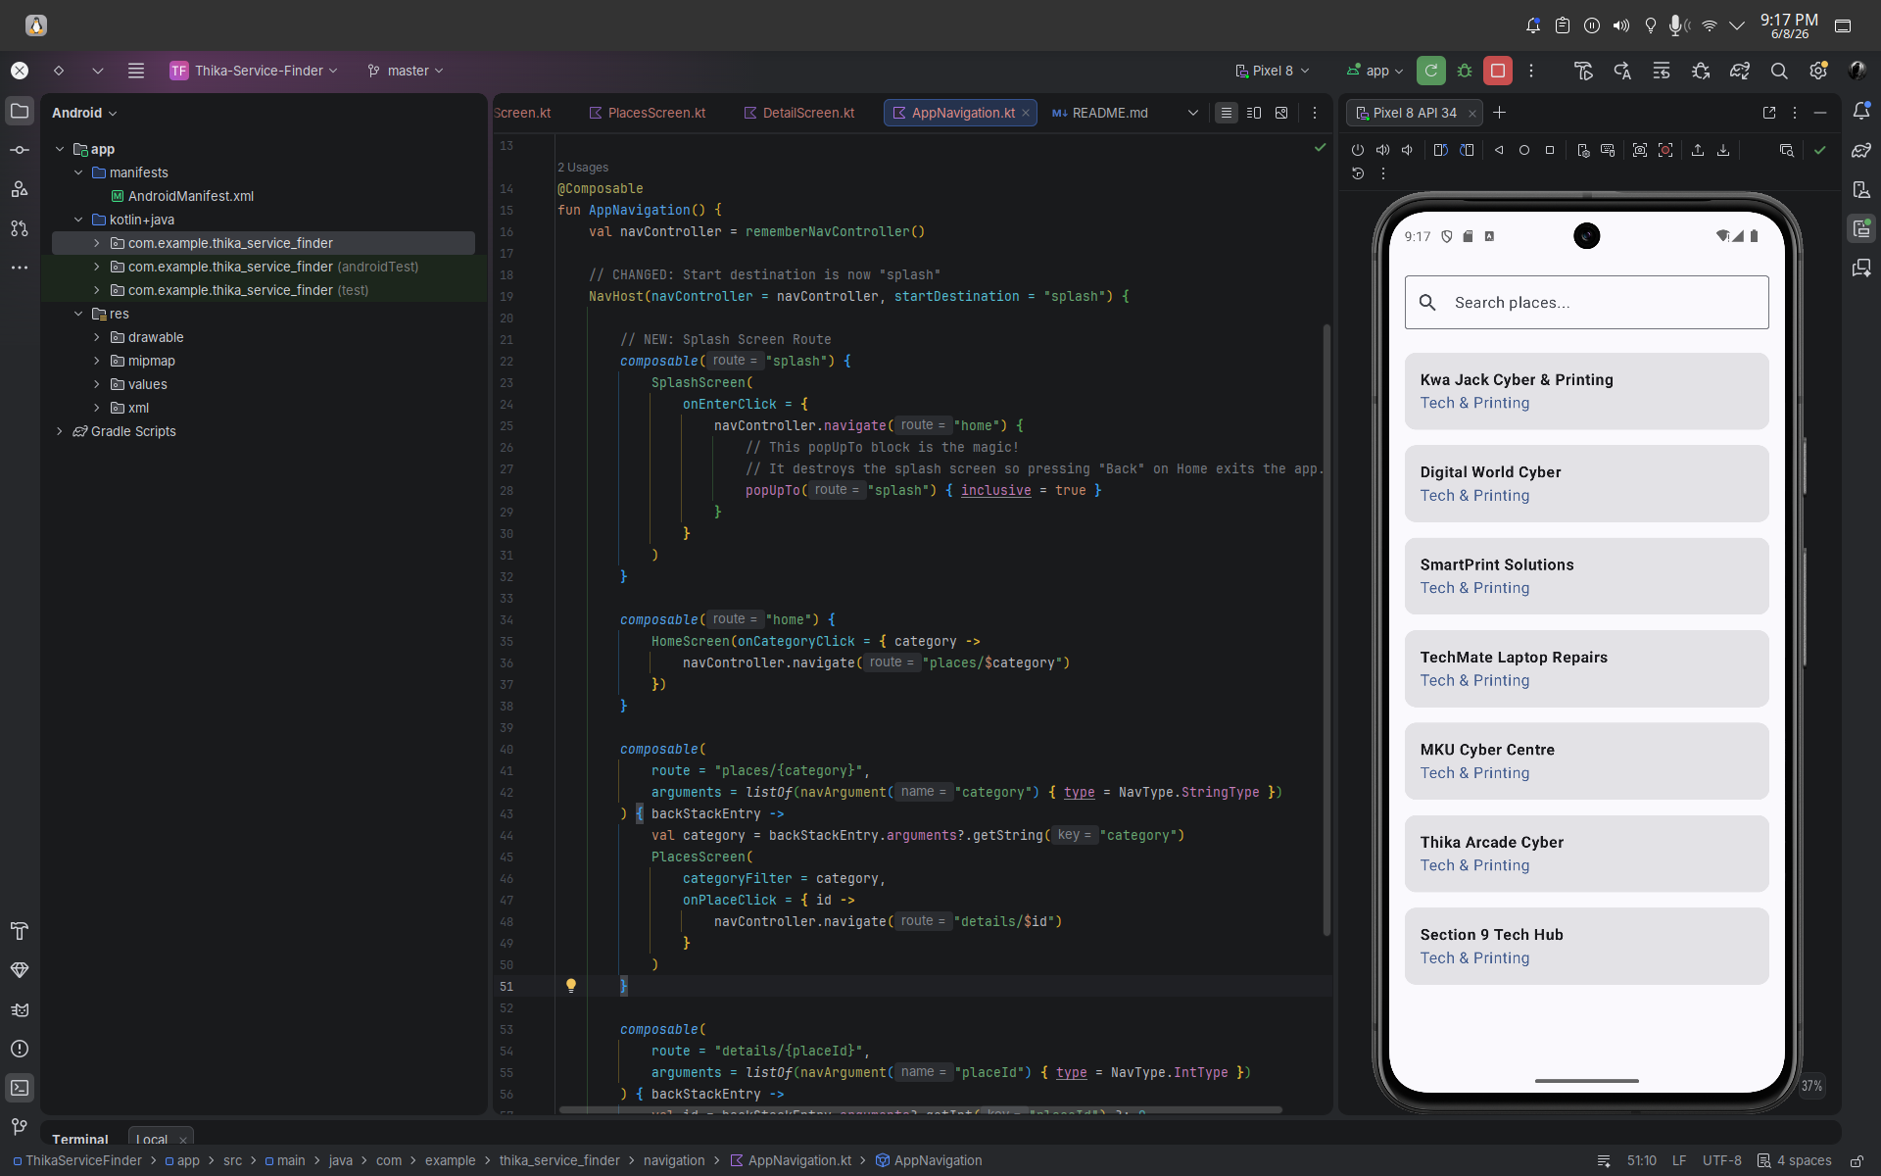

Figure 4.2: Splash screen entry point
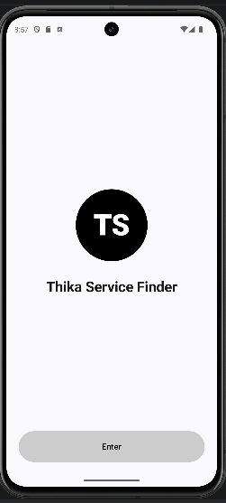

Figure 4.3: Main dashboard interface

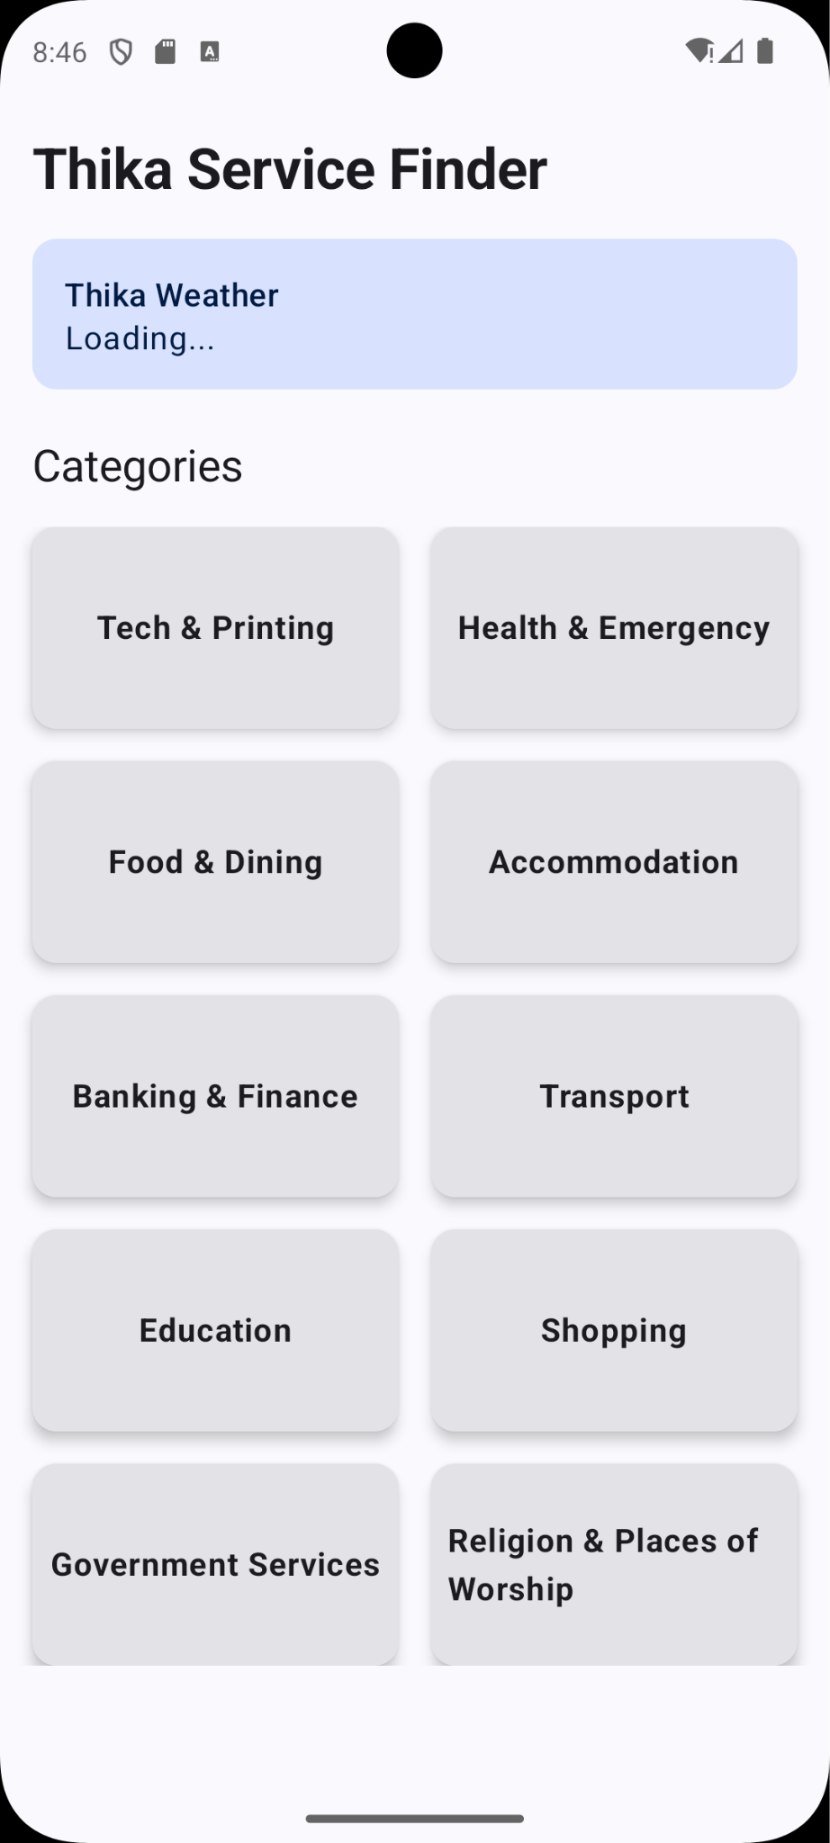

Personal Reflection
Translating wireframes into Kotlin code within Android Studio has been a game-changer. While I initially encountered several compilation errors, the integrated Gemini AI significantly streamlined the debugging process, effectively acting as an intelligent agent to identify and resolve issues quickly.

Week 5: Data Management

Figure 5.1: Local data storage configuration
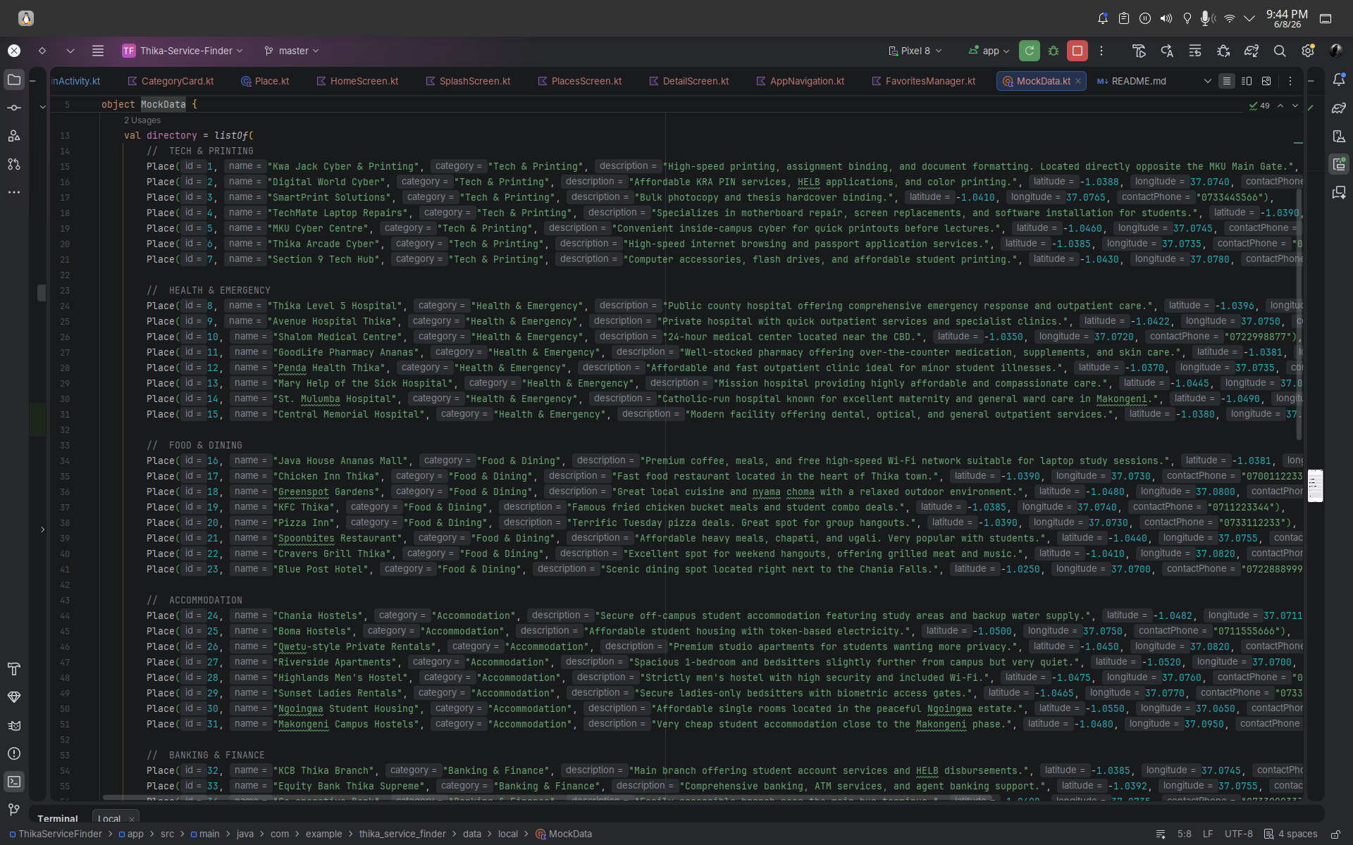

Figure 5.2: FavoritesManager.kt for persistent storage
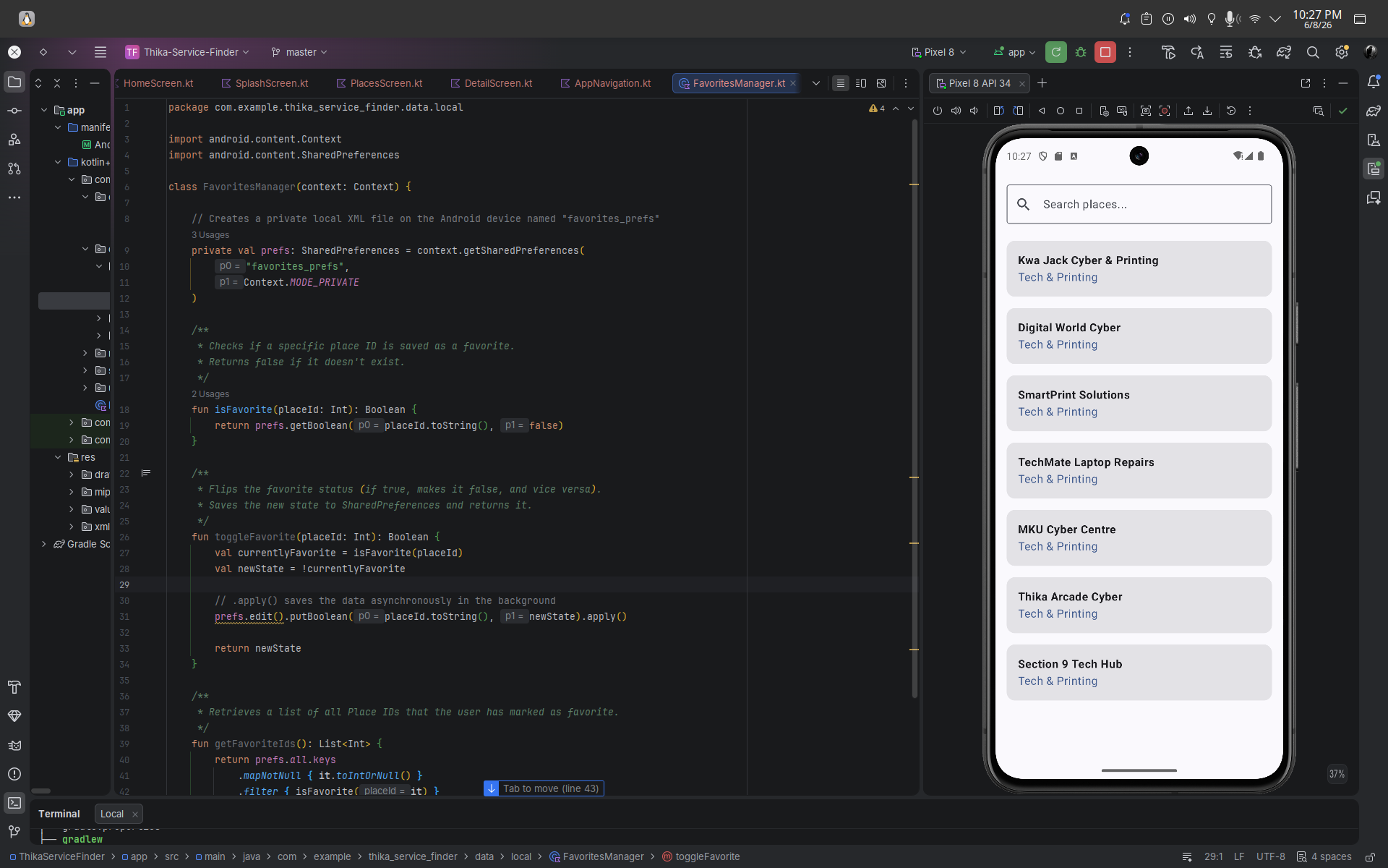

Figure 5.3: Places List screen in emulator
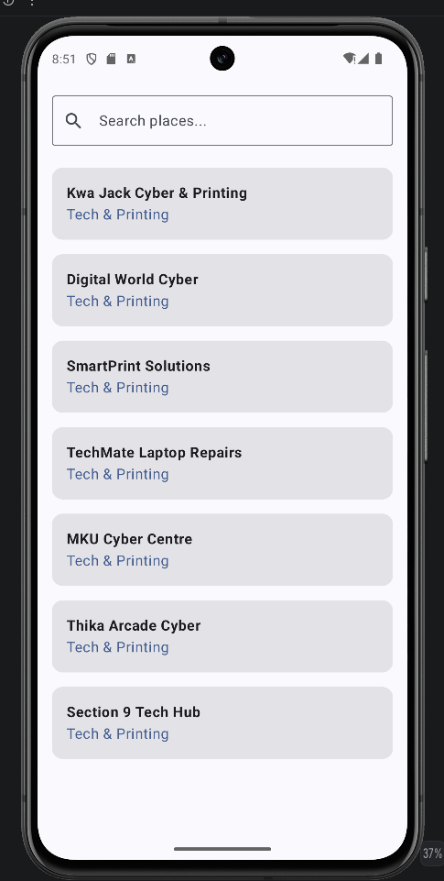

Personal Reflection
This week, I implemented robust data management using SharedPreferences to handle user favorites. I successfully created the FavoritesManager to persist key-value pairs, ensuring offline data accessibility. This experience deepened my understanding of CRUD operations and efficient local storage implementation, significantly enhancing the app's user experience and functionality.

